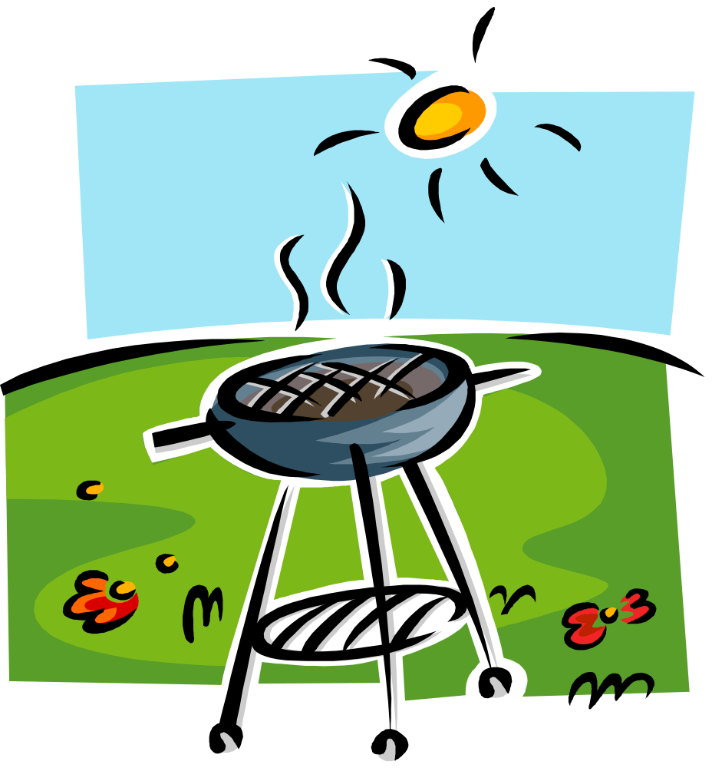
Call or sign up to bring side dishes, condiments or utensils.

Stephanie - 303-520-7821
Dellene – 720-394-2423
Bring your kids
Bring your games
Donations accepted

Sunday July 26
Paramount Park
27th & Kipling on West Side
11 AM – 5 PM

Bring something to
share with others!

